**INSTALLATION STEPS FOR X-CTU**

X-CTU is a Windows-based application provided by Digi. This program was designed to interact with the firmware files found on Digi’s RF products and to provide a simple-to-use graphical user interface to them.

**Software requirement:**

X-CTU is designed to function with all Windows-based computers running Microsoft Windows 98 SE and above.

**Step 1:**

Double click the “Setup_XCTU_5260.exe” in Software and Drivers folder provided in e-Yantra_DVD.

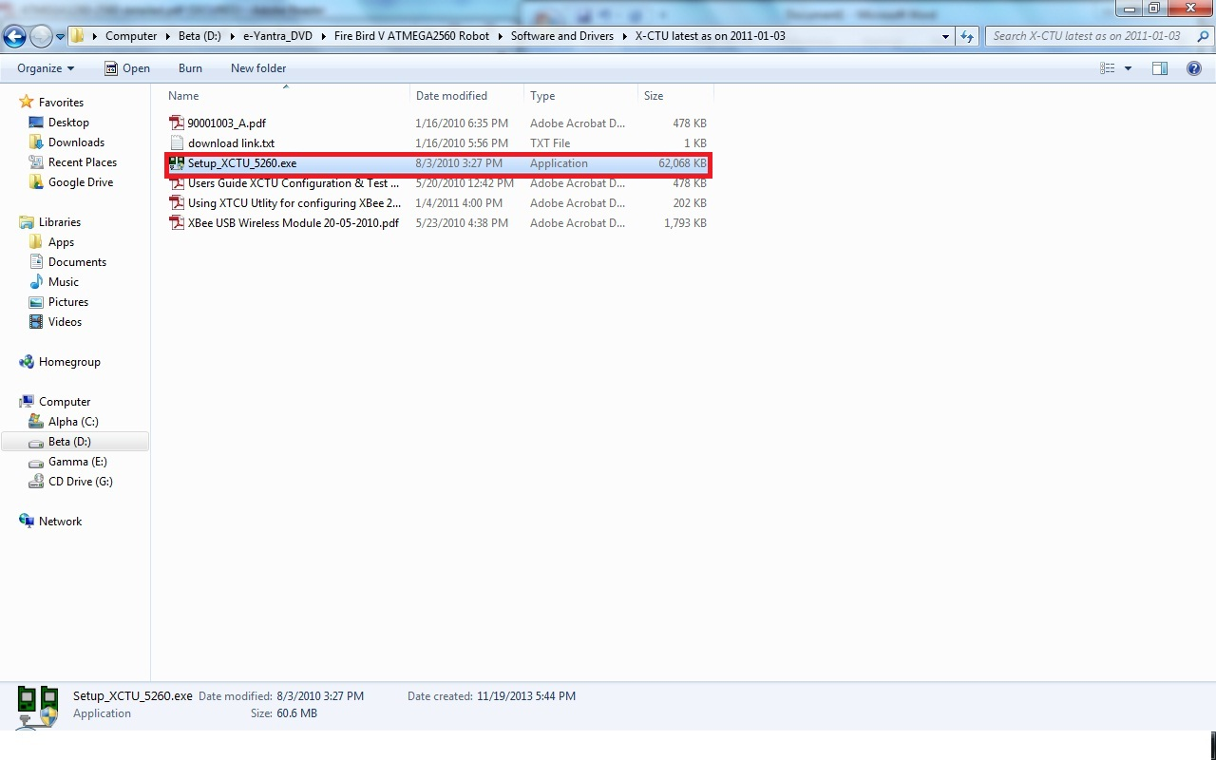

**Step 2**:

Enter next as shown in figure.

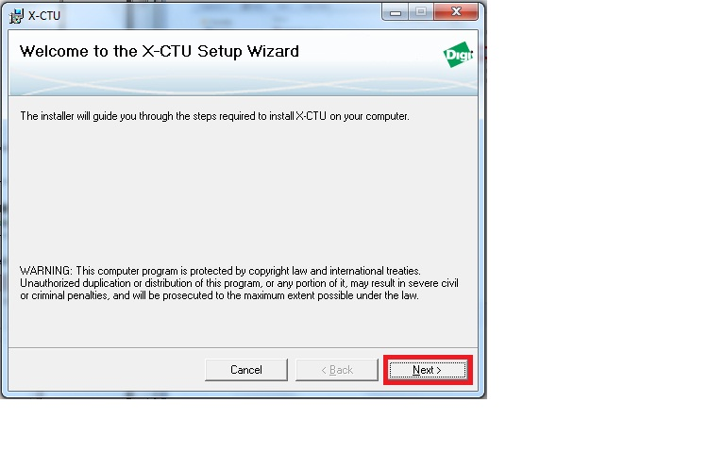

**Step 3**: Select “I Agree” and press NEXT.

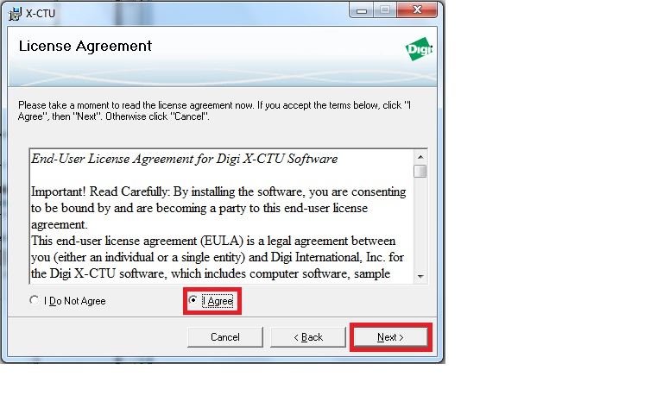

**Step 4**:

Select an installation folder and press NEXT.

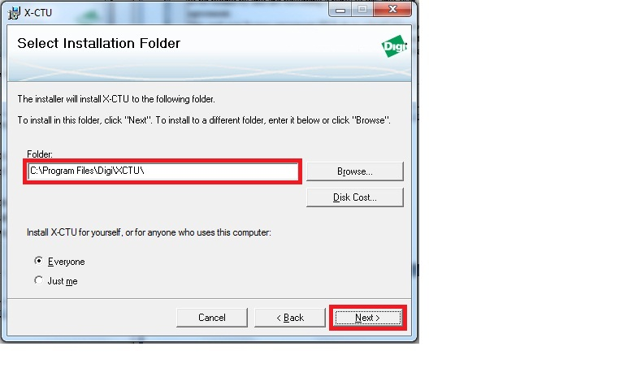

**Step 5**:

Click “NEXT” to start the installation.

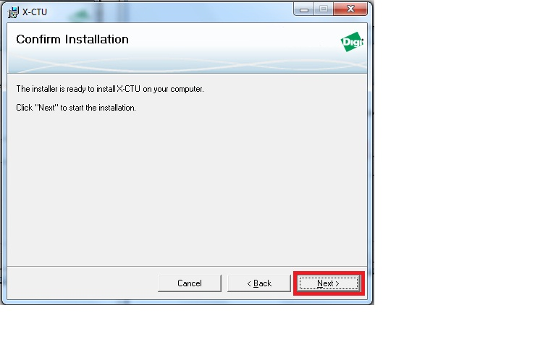

**Step 6**: The installation will take about five minutes to complete.

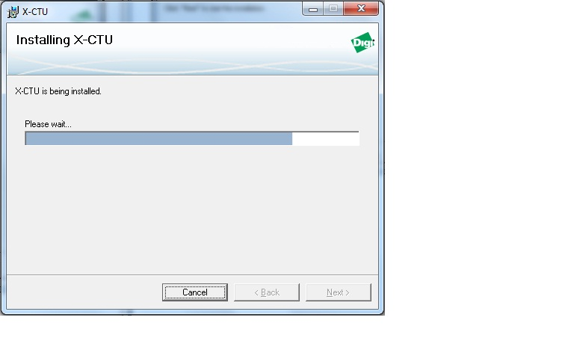

You have now successfully installed X-CTU . Click “close” to exit.

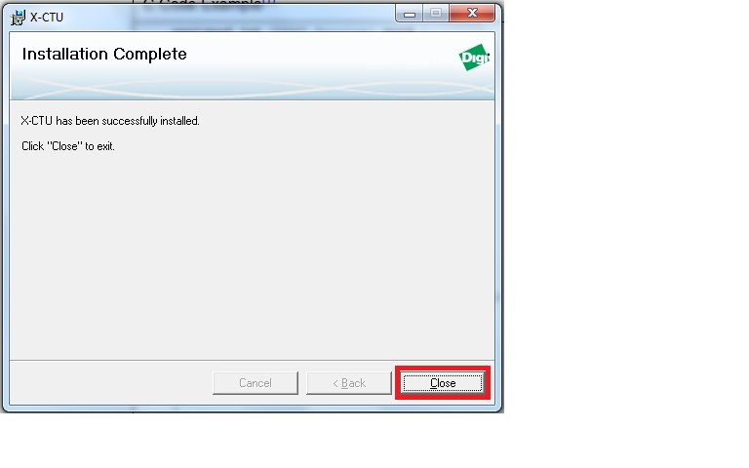

When properly installed it can be launched by clicking on the icon on the PC desktop (see Figure 1) or selecting from the Start menu (see Figure 2).

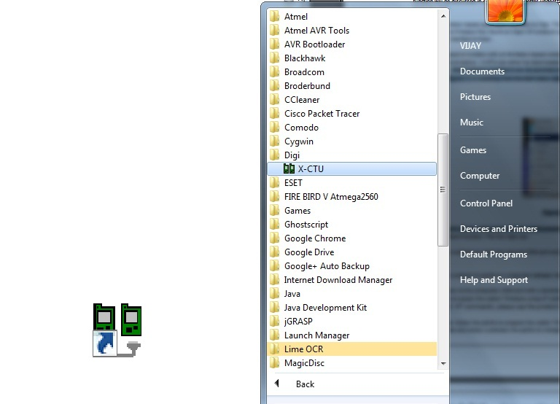

Figure 1

Figure 2

Figure 2

Figure 1